Lesson 2 – My room

- 1 These are the pictures of Tia's room.
Ovo su slike Tijine sobe.

a) Look at the picture A and B.
Prouči sliku A i B.

b) Find and circle the differences.
Pronađi razlike i zaokruži ih.

A
A

B

- 2 Look at Tia's room.
Prouči sliku Tijine sobe.

Cross out the things that you can see in the room.
Prekriži nazive za stvari koje su na slici.
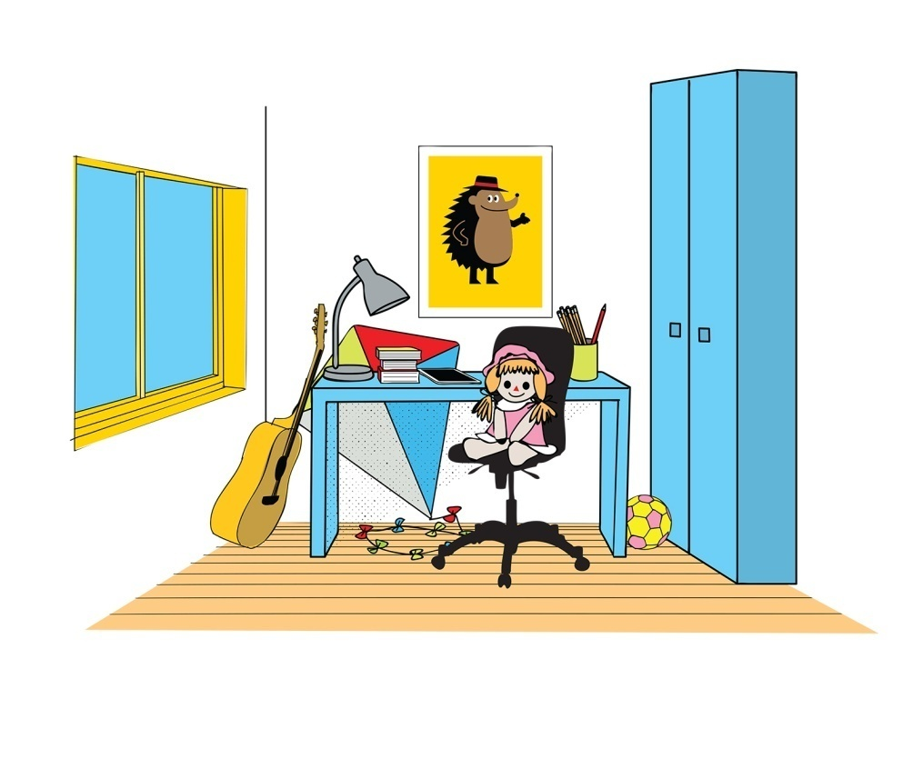

curtains
zavjese
a wardrobe
ormar
a fridge
hladnjak
a window
prozor

a picture
slika
a lamp
svjetiljka
a chair
stolica
a cooker
štednjak
a desk
radni stol

- 3 Look at the pictures. Where is the cat?
Pogledaj slike. Gdje je mačka?
a) Listen to your teacher describe the pictures.
Poslušaj učitelja kako opisuje slike.
b) Point to the pictures your teacher is describing.
Pokaži slike koje tvoj učitelj opisuje.
c) Say the sentences after your teacher.
Ponovi rečenice nakon učitelja.

1 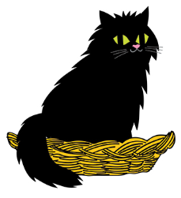 2 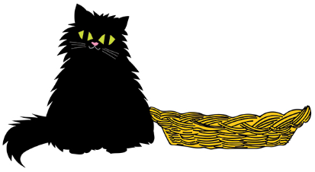
ON NEXT TO

3 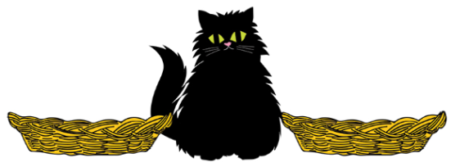 4 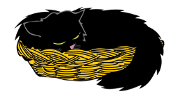
BETWEEN IN

5 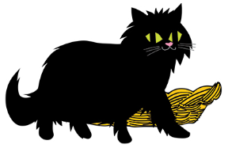 6 
IN FRONT OF BEHIND

7 
UNDER

- 4 Look at the pictures.
Pogledaj sličice.
a) Read the sentences with your teacher.
Pročitaj rečenice uz pomoć učitelja.
b) Underline There is / There are. What is the difference?
Podcrtaj izraze: There is / There are. U čemu je razlika?

Do you remember?
Sjećaš li se?
One (1)  Jedan / jedna | 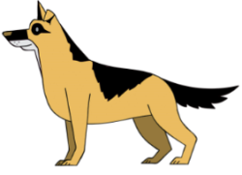  More  Više
a dog | dogs
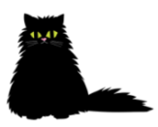  a cat | cats

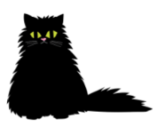


1

There is a cat in the basket.
Mačka je u košari.

2

There are cats in the basket.
Mačke su u košari.

3


There is a dog between the baskets.
Pas je između dvije košare.

4
There are dogs between the baskets.
Psi su između dvije košare.

5

There is a cat next to the basket.
Mačka je pored košare.
6
There are cats next to the basket.
Mačke su pored košare.

- 5 Choose and circle : There is or There are.
Izaberi i zaokruži jedninu (There IS) ili množinu There ARE).

1

There is / There are a cat in the basket.
Mačka je u košari.
2

There is / There are cats in the basket.
Mačke su u košari.
.3

There is / There are a cat next to the basket.
Mačka je pored košare.

4
There is / There are dogs between the baskets.
Psi su između dvije košare.
5
There is / There are cats next to the basket.
Mačke su pored košare.
6

There is / There are a dog between the baskets.
Pas je između dvije košare.

- 6 Look at the pictures.
Pogledaj sličice.
Read the sentences with your teacher.
Pročitaj rečenice uz pomoć učitelja.

1

There is a cat in the basket.
U košari je (jedna) mačka.

2

There isn't a cat in the basket.
U košari nije mačka.

3

There are dogs next to the basket.
Psi su pored košare.

4

There aren't any dogs next to the basket.
Pored košare nisu psi.

- 7 Circle the correct option: is, isn't, are or aren't.
Zaokruži točnu riječ: je, nije, su ili nisu.

1
There is / isn't a dog in the basket.
U košari je/ nije pas.

2

There is / isn't a dog between the baskets.
Između košara je/nije pas.

.
.
3

There is / are a cat in the basket.
U košari je/nije mačka.

4

There isn't / aren't any dogs in the basket.
U košari su/nisu psi.

5

There are / aren't cats next to the basket.
Pored košare su/nisu mačke.

- 8 Do you remember Tia's room?
Sjećaš li se Tijine sobe?
Use the words from the box.
Koristi riječi iz okvira.
Do you remember?
Sjećaš li se?
is | je
isn't | nije
aren't | nisu
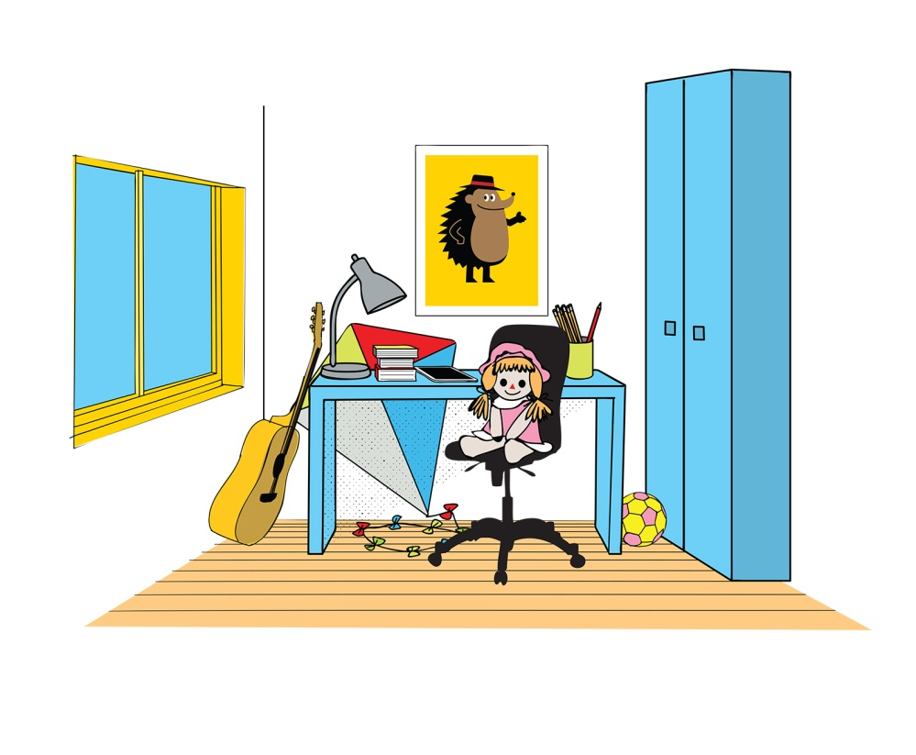

1 There is a window.
U sobi je prozor.
2 There ___________________ a fridge.
U sobi nije hladnjak.
3 There ___________________ a wardrobe.
U sobi je ormar.
4 There ___________________ curtains.
U sobi nisu zavjese.
5 There ___________________ a desk.
U sobi je radni stol.

6 There ___________________ a cooker.
U sobi nije štednjak.
7 There ___________________ a chair.
U sobi je stolica.
8 There ___________________ a picture.
U sobi je slika.
9 There ___________________ a lamp.
U sobi je svjetiljka.

- 9 Look at the room in task 7 once again.
Prouči sliku sobe u zadatku 7.
Where are the things?
Gdje se nalaze stvari?
Use the words in the frame.
Upotrijebi riječi iz okvira.

BEHIND NEXT TO IN FRONT OF

UNDER ON BETWEEN

1 There is a desk UNDER the picture.
Radni stol je ispod slike.
2 There is a chair _________________ the desk.
Stolica je ispred radnog stola.
3 There is a wardrobe ______________ the desk.
Ormar je pored radnog stola.
4 The desk is __________________ the chair.
Radni stol je iza stolice.
5 There is a lamp __________________ the desk.
Svjetiljka je na stolu.
6 The desk is ________________ the window and the wardrobe.
Radni stol je između prozora i ormara.

